Name: Mriganka Patra
Email: mriganka.patra@cognizant.com
Emp ID: 2415820

Day 18
Sprint 1 Submission

Task 1.2: As a CRM user, I want to see the age of a contact calculated from their birthday so that I can segment users by age group.

- Go to object Manager

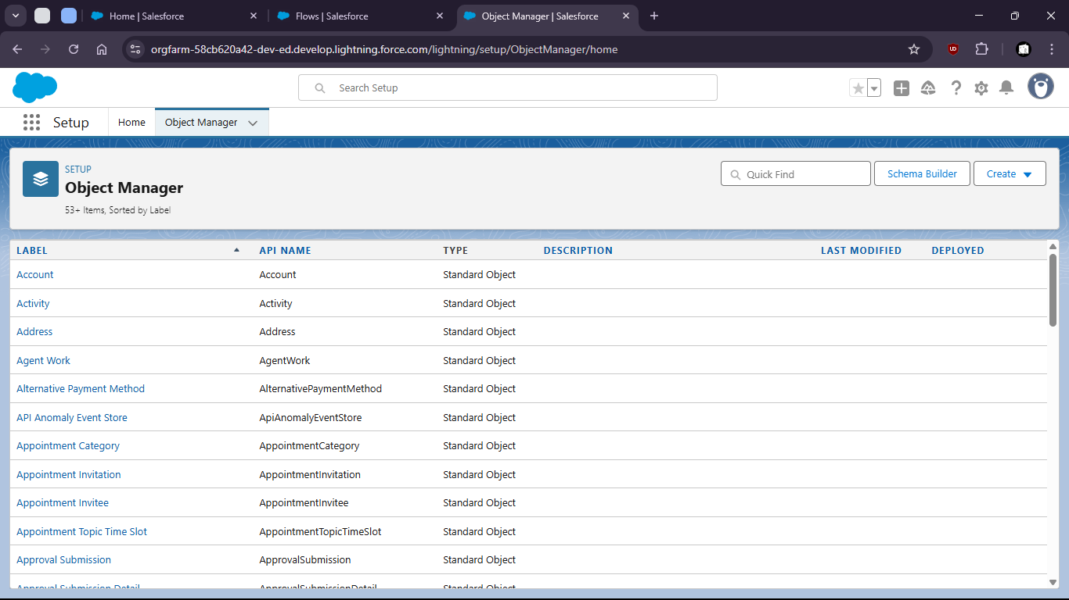

- Select Contact object

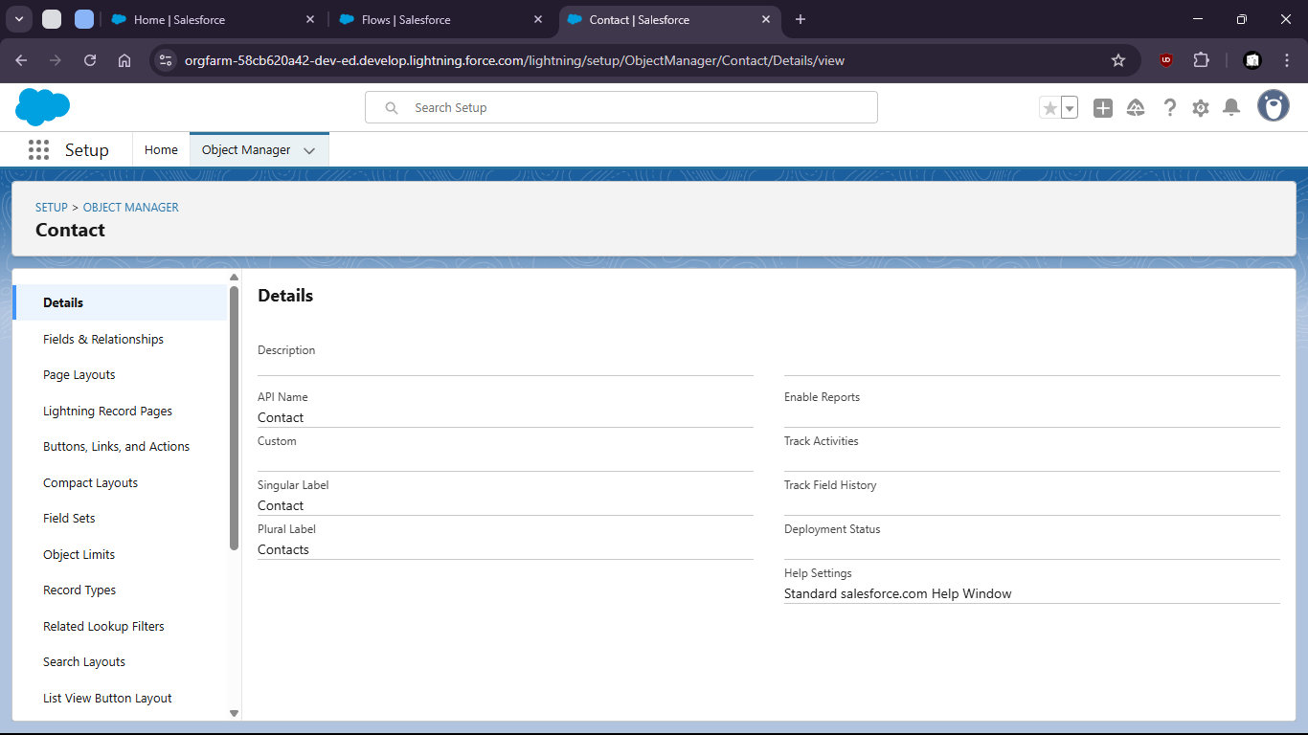

- Go to the fields and relationships

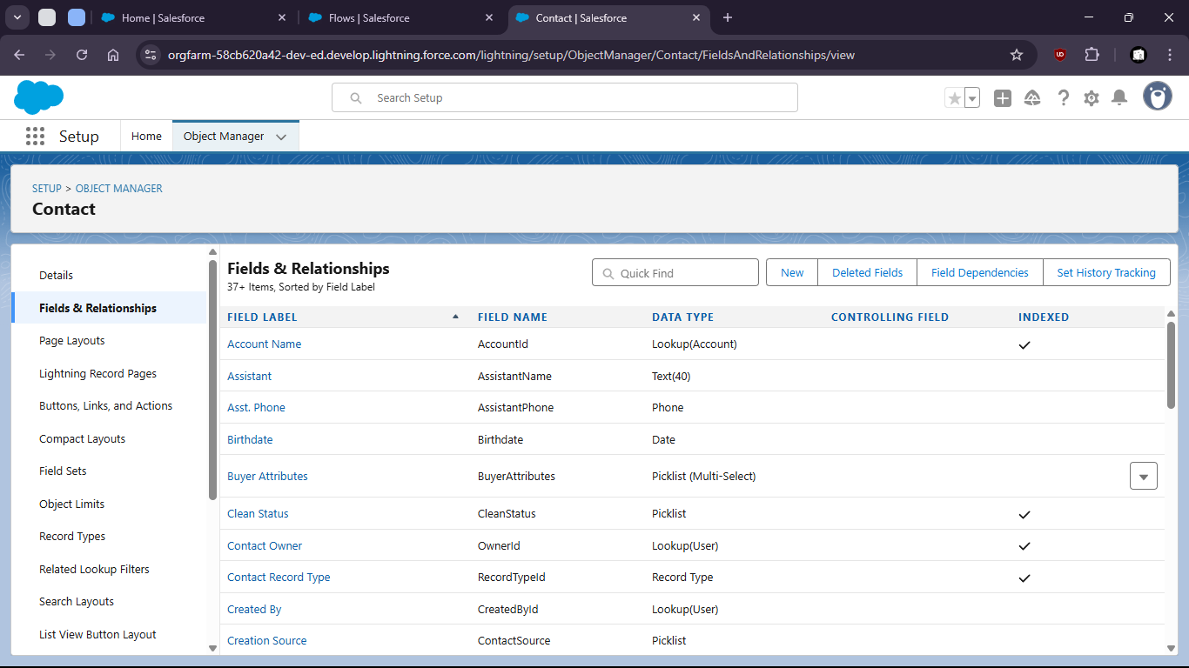
- Create a new Field as Formula

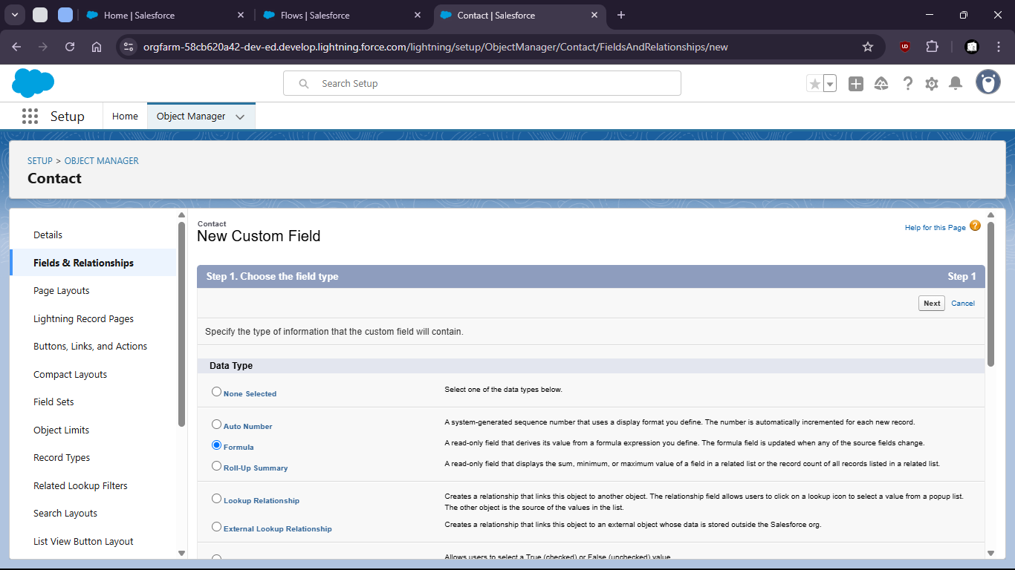

- Give name and type

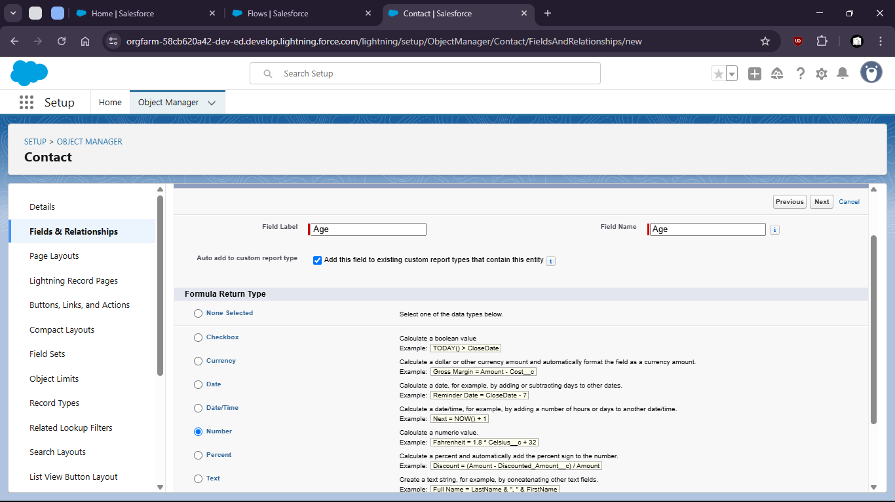

- Enter the formula with proper syntax

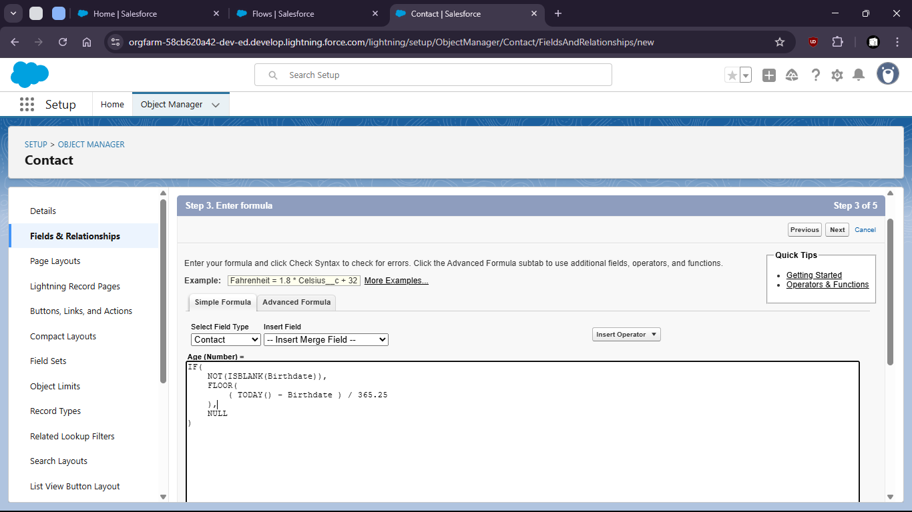

- Setup field level security and save

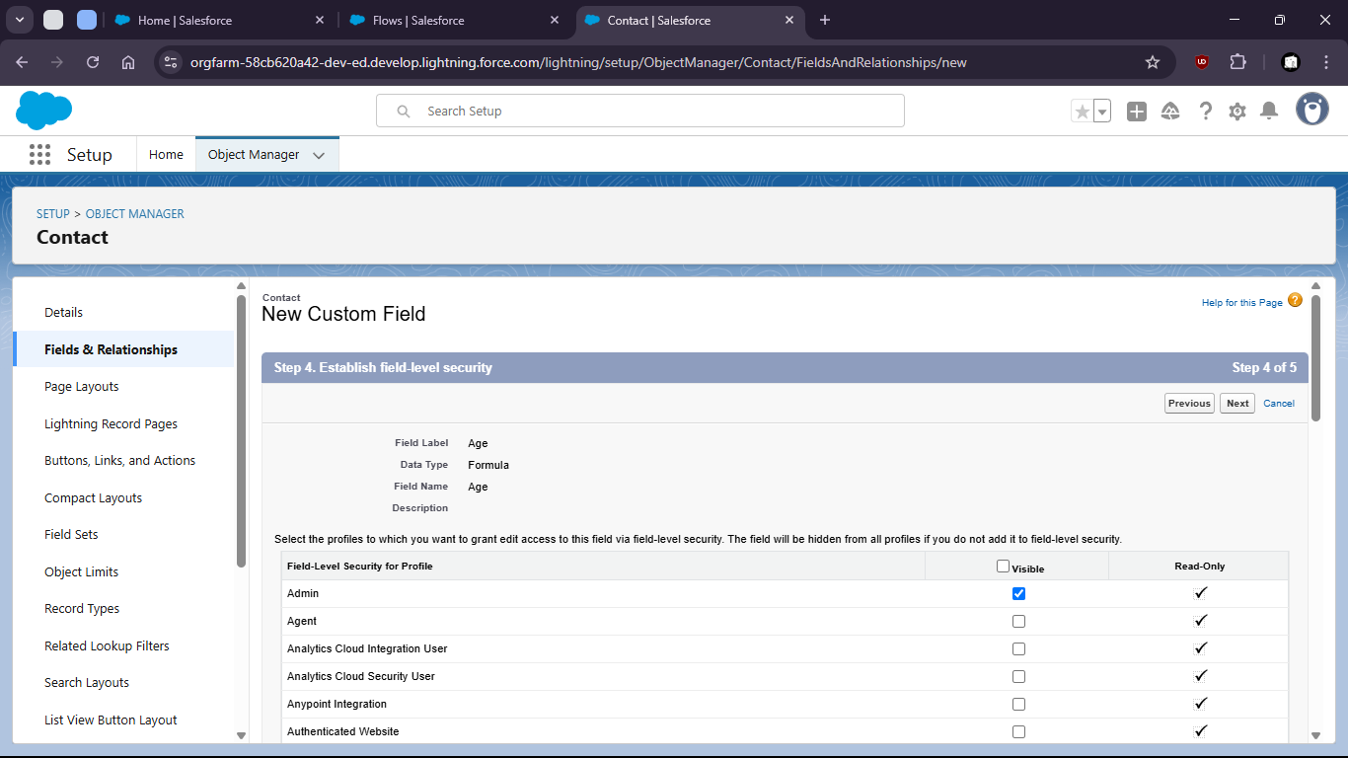

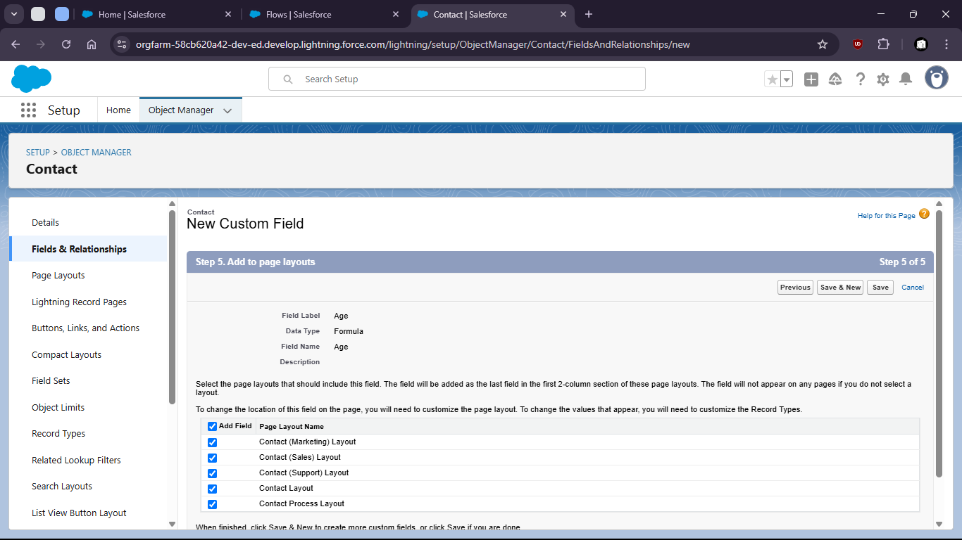

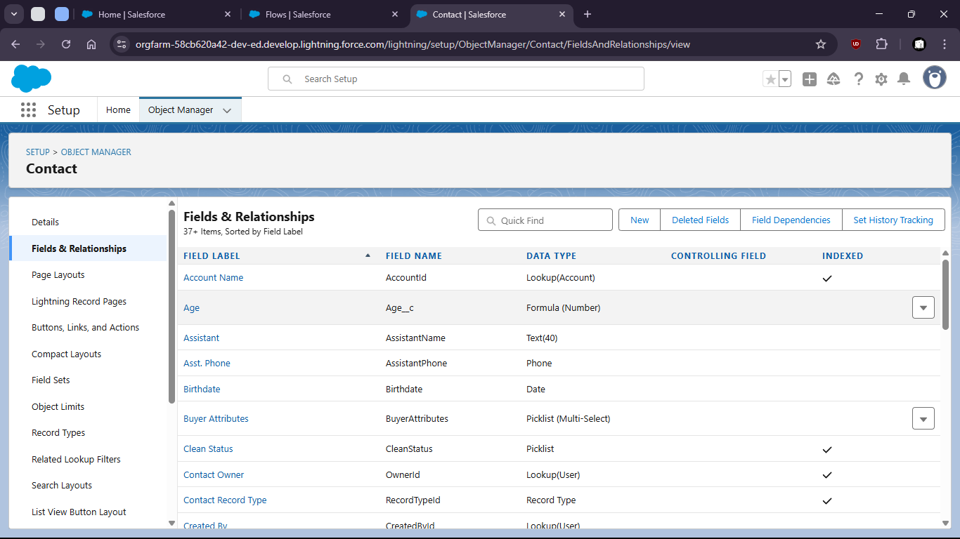

- Now verify the field is working or not.

- Go to contacts > create new contacts

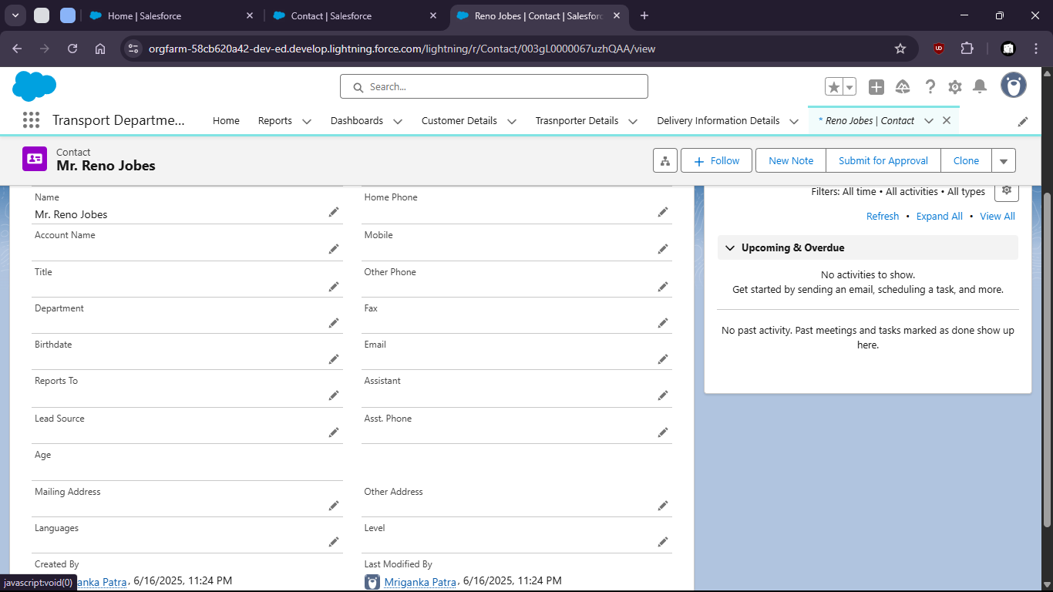
- When no Birthdate given the age shows empty (NULL)

- But when we put a Birthdate the age is calculated

